NAME: _____________ | Algebra
Slope / Yintercept | DATE: Wednesday, June 14, 2017
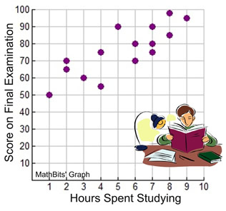
You graph hours people studied and scores:

You draw a trendline and get the equation y=6.7x+42
What does the slope mean in real terms?

What does the y intercept mean?

A graph of a motorcylces price and its age is below
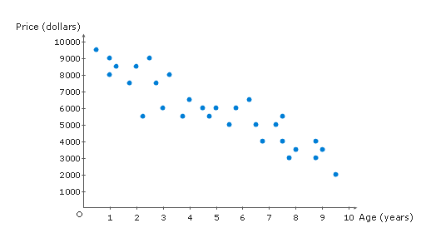
You find the trendline and its equation is y= -850x+10,500
What does the slope mean in real terms?

What does the y intercept mean?

A graph of temperature and sales of coffee (in pounds) is below:
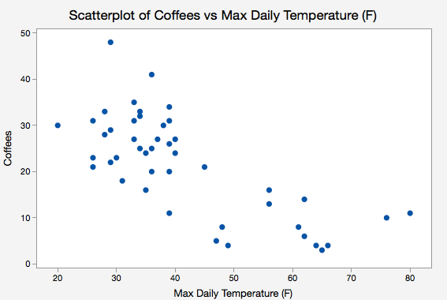
You draw a trendline and get the equation y= - 1.5x + 62
What does the slope mean in real terms?

What does the y intercept mean?

